**A data driven AI framework for conversational bot by vision transformers in health care systems.**

*Sudharson D1, Noor Surraya S M 2, S Oviya Retheneka3, Dharshini R4,

Shankari S5  and Sriram P6

Kumaraguru School of Innovation, Kumaraguru College of Technology,

Coimbatore, India.

{sudharsondorai.ads, noorsurraya.20ad, oviyaretheneka.20ad, dharshini.20ad, shankari.20ad, sriram.20ad}@kct.ac.in

**Abstract.** Artificial intelligence (AI) is a disruptive force that increases productivity and provides innovative solutions to difficult issues in many sectors. When it comes to natural remedies and healthcare, artificial intelligence has particularly fascinating possibilities. This project intends to create a system that integrates artificial intelligence, natural language processing, and image recognition to create a powerful tool for Medicinal Plant Identification and to answer related queries. AI's capacity to enable precise identification and provide insightful information about the wide range of natural therapeutic uses makes it important to incorporate it into the field of medicinal plants. Since medicinal plants have been utilized for their curative qualities for ages in many cultures, artificial intelligence (AI) adds a new perspective by offering a methodical and cutting-edge scientific approach to their identification and applications. The proposed system produces a reliable resource for identifying medicinal plants through the use of deep learning models, called vision transformers (ViT) for image recognition and has achieved a high accuracy of 99% providing an efficient and optimal result. Additionally, this approach enables users to get comprehensive information about the therapeutic properties of plants through the ChatBot developed using a pre-trained Large Language Model(LLMs) upon custom data. This concept acknowledges the necessity for individualized information beyond simple identification and guarantees users to engage in meaningful conversations about certain plants and their medical advantages. This holistic approach automates the process of identification and enables a way to understand the natural medical qualities of the plants**.**

**Keywords:** Artificial Intelligence, Natural Language Processing, image recognition, medicinal plants, Vision Transformers, Large Language Models.

**1 Introduction**

In the realm of healthcare and biodiversity, the intersection of artificial intelligence in medicinal plant identification and chatbot creation presents a promising frontier. This research aims to develop an integrated system merging a robust medicinal plant identification module with a conversational bot for detailed information. Leveraging AI technologies, including vision transformers and natural language processing, the system seeks to enhance the accuracy of plant identification while providing accessible insights into medicinal plant properties. The research tries to enable users to experience and address ethical considerations, meanwhile bridging traditional knowledge with modern technologies for sustainable and informed use of medicinal plants. Medicinal plants are botanical species that contain substances having therapeutic properties; these species can help with the prevention, treatment, and alleviation for a wide range of ailments. Traditional healers handle issues related to community health by utilizing their expertise of the local flora. They often take the role of defenders of this ancient knowledge. However, the traditional methods of identifying and cataloging medicinal plants are often time-consuming and require specialized botanical expertise. In the twenty-first century, there has been a resurgence of interest in natural remedies, and integrative medical techniques have gained acceptance.

Additionally, many communities, particularly in developing regions, have little access to modern medical facilities, thus they primarily rely on traditional herbal medicines. On examining the difficulties in identifying therapeutic plants and the right use of its properties in the modern era, this imposes the importance of medicinal plants in the well-being of humans and elevates the topic of tremendous legacy and change.

The goal of this project is to develop a smooth and effective system for medicinal plant identification on utilizing artificial intelligence and to enable both specialists and amateurs to correctly identify medicinal plants while utilizing cutting-edge computer vision techniques and deep learning algorithms. Simultaneously, this project presents an interactive conversational bot that aims to enable an interactive information exchange system. Moreover, it lets the users have natural conversations about medicinal plants with the bot, which acts as a link between the scientific community and the general population. The bot's adoption of Natural Language Processing and Large Language Model capabilities makes it a useful instrument for knowledge sharing, and the revelation of traditional plant-based medicinal wisdom.

On investigating the difficulties, prospects, and the moral issues that are related to applying AI technology in the field of medicinal plants, we delve into the technical details of this integrated approach.With the following approach, this research aims to further associate the growing story of artificial intelligence applications by highlighting the role of AI in both technological innovation and the establishment of a closer relation between humans and the natural world. Therefore the intent is to create a more peaceful cohabitation of scientific advancement and conventional wisdom by integrating AI with the identification of medicinal plants and the chatbot creation in a symbiotic manner.

**2 Literature Review**

As it has been known for numerous centuries that medicinal plants contain compounds that have the ability to heal mankind. Recognition of such plants along with their right therapeutic use cases has always been a crucial part of traditional medicine. With AI integration, where computer vision aids in identifying the features and patterns of plant parts which in turn helps with accurate detection of medicinal plants and the Natural Language Processing (NLP) leverages the potential of understanding the therapeutic uses of plants that benefit people. The application of artificial intelligence (AI) to the identification of medicinal plants has attracted a lot of interest, which led to a thorough investigation through this review of the literature. The principal aim is a comprehensive assessment of current research that utilizes artificial intelligence methods, namely in the fields of computer vision and machine learning. The focus of this landscape is on identifying trends, challenges, and opportunities. Of particular note is the use of advanced AI architectures, such as Large Language Models (LLMs) and Vision Transformers (ViTs), to augment the capacities of plant identification systems.

The potential of Vision Transformers (ViTs) to transform computer vision and image processing makes them important for the identification of medicinal plants. ViTs are an innovative method of image identification that do away with the requirement for manually created features and instead rely on self-attention mechanisms, which sets them apart from conventional Convolutional Neural Networks (CNNs). This change in architecture has particular effects on how medicinal plants are identified: Understanding Global Context, Decreased Dependency on Specified Features, Improved Extraction of Features, Generalization and Transfer Learning, Flexibility with Diverse Datasets, Possibility of Explainability. Large Language Models (LLMs) with sophisticated natural language processing capabilities can be used to create a great deal of useful chatbots for medicinal plants. Mistral 7B, a recently released LLM, has demonstrated exceptional performance in terms of chatbot quality and response rate. The following are the main abilities: Contextual Responses, Conversational Flow, Knowledge Integration, Natural Language Understanding, and Flexible User Interaction.

In one instance, a deep learning methodology was used to investigate Ayurvedic leaf classification [1], using Support Vector Machines and Convolutional Neural Network (CNN) models. In the same line of thought, a work on deep learning for medicinal plants [2] that used CNNs and the VGG-16 model with transfer learning not only showed better outcomes but also addressed issues with overfitting and data quality. CNNs and pretrained Visual Geometry Group (VGG) models were incorporated in other research work on native medicinal plants [9], leading to a thorough comparison that demonstrated the superior performance of pretrained models in assisting research in medical domains. Our suggested system's thoughtful integration of ViTs and LLMs is in line with the current developments in AI applications, enhancing our comprehension of plant characteristics and therapeutic features. Furthermore, a study described a real-time method for classifying medicinal plants that was based on logistic regression classification and the ExG-ExR index for leaf segmentation. While the goal of the research was obviously to improve the system's capacity to assess various plant sections, especially in complex scenarios, it was accomplished with an excellent accuracy rate.

In aggregate, these studies—including the study based on ViTs and LLMs—mark important advancements in the field of AI-based medicinal plant identification. Our suggested system's intentional fusion of ViTs and LLMs is a tactical step forward in utilizing state-of-the-art AI architectures. For the ethical and successful integration of AI in traditional medicine, the focus on standardizing datasets, improving model generalization, and addressing ethical issues is still crucial. Future studies and contributions should continue to investigate and improve these areas, advancing the science toward increased efficacy and moral concerns in the identification of medicinal plants.

**3 Datasets**

**3.1 Indian Medicinal Plants Dataset**

With 120 different plant species displayed, the Indian Medicinal Plant dataset contains a vast collection of photos of medicinal plants. The dataset has been carefully selected to provide a realistic portrayal of plants in various environmental contexts. Images have been taken in a variety of lighting and background circumstances. It is divided into two directories, one with images of various plant components and the other concentrating on the leaves of the plants. In order to ensure a comprehensive and balanced representation for reliable analysis, the dataset is enhanced with 80 distinct classes for images of leaves and 40 classes for images of other plant parts. Notably, there are more than 80 images in each class, showcasing a wide variety of plant species. These jpg-formatted photographs add a level of complexity with their varied backgrounds, making the dataset more useful in practical situations. With plenty of images to examine and recognize patterns and traits across several plant species, this dataset proves to be an invaluable tool for scholars as well as professionals in the field of medicinal plant identification. Furthermore, Fig. 1 provides a representative overview of the dataset's contents by highlighting a few of the dataset images. The quantity of images in each class and their visual depiction highlight the importance of the dataset as a vital resource for the advancement of research in the identification and categorization of medicinal plants.

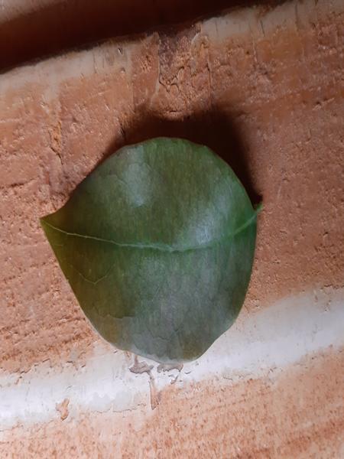 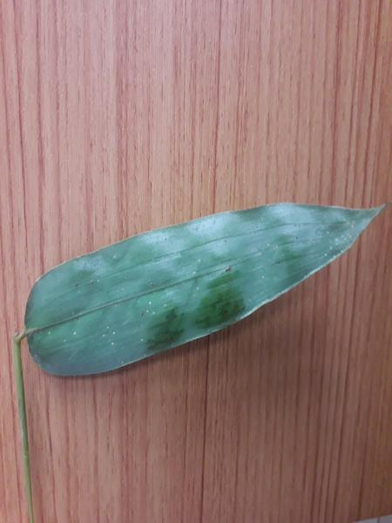 

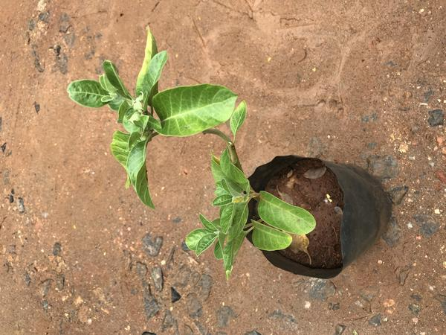 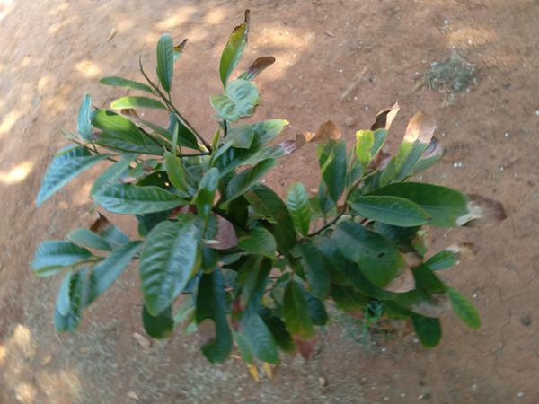

**Fig.1.** Dataset İmages

**3.2** **Floramed Data**

A curated dataset called "floramed" gathered from multiple sources, has been used to create an interactive chatbot for asking questions about different medicinal plants and their therapeutic purposes. The collection now contains information on 50 different types of medicinal plants. Users looking for information on the characteristics, identification, and many medical uses of medicinal plants might benefit greatly from this well compiled data. The material in the dataset has been carefully gathered from a variety of publications and books to guarantee its dependability and correctness. Every dataset item provides in-depth information about the corresponding medicinal plant, setting the stage for an intuitive chatbot interface that can reliably and informatively respond to natural language inquiries regarding medicinal plants.

**4 Methodology**

**4.1 Proposed Framework**

A novel approach to recognize medicinal plants is represented in this research, which utilizes Vision Transformers (ViT) and incorporates with Hugging Face's model hub thereby extending its application by developing an interactive chatbot that aids users in gaining information about the scientific background and the significant therapeutic uses of medicinal plants. The project commences with the comprehensive gathering and preparation of data, which produces a diversified dataset of medicinal plant snapshots and a custom data with the detailed information of most of the plants. The medicinal plant dataset is appropriately labeled and mapped to support future model training.

The recognition of medicinal plants is achieved by capturing the subtle relationships between leaf textures, vein patterns or structural aspects throughout the entire image of the plant. This process has significantly advanced with the use of Vision Transformers (ViTs) recognizing medicinal plants, by analyzing the whole image at once. They excel at capturing long-range connections between distant features, understanding spatial arrangements like the relative positions of petals, leaves, stems and focusing on key details like textures and shapes. Unlike conventional methods, ViTs dynamically adjust their focus based on the specific plant, capturing subtle variations and learning higher-level features implicitly. This adaptability makes them robust across different image formats, paving the way to accurately differentiating similar-looking plants with slight variations in arrangement and with subtle differences in features.

The chosen ViT architecture, sourced from Hugging Face's model hub, undergoes fine-tuning with special attention to hyperparameters and regularization algorithms. The model's evaluation criteria, such as accuracy and F1 score, serve as reliable predictors of its success. Simultaneously, the pre-trained model “Mistral-7B-v0.1” for chatbot development can be finetuned with the custom medicinal plant data which enables to build an engaged and an efficient chatbot system with its attention mechanisms, long sequence lengths and generative capabilities.

Conclusively, the interpretability of the model's judgments is further investigated, revealing insights into the attention mechanisms enabled by the Transformers. Importantly, the model is fully integrated with Hugging Face's model center, which enables in simplifying sharing and deployment. This integration enhances collaboration and access within the scholarly community. The suggested approach not only demonstrates promising results but also aligns with Hugging Face's mission to promote and democratize artificial intelligence technologies.

**4.2 Vision Transformers(ViT)**

AI has profoundly transformed computer vision, empowering machines to perceive and understand the world through a range of techniques. Machine learning, encompassing supervised, unsupervised, and reinforcement learning, facilitates diverse tasks like object identification, image segmentation, and anomaly detection. Deep learning, notably convolutional neural networks (CNNs), excels at extracting image features, proving invaluable in fields such as medical image analysis and style transfer. Additionally, generative models and transfer learning play crucial roles in creating new images and leveraging pre-trained models for improved performance across tasks. While CNNs have long been dominant in image classification, a new contender, Transformers, originally designed for natural language processing, is gaining traction in computer vision for its remarkable ability to capture long-range dependencies in images.

The paper entitled "Attention is all you need" published in 2017, marked the turning point in Natural Language Processing and related tasks. This is initiated by the Transformers architecture that predominantly merged attention mechanisms with Residual Neural Networks (RNNs), that eliminates the challenge of capturing long term dependencies. Conventionally, a novel and inventive study made a breakthrough on successfully adapting Transformers for image recognition and image related tasks, that surpasses the capability of Convolutional Neural Networks. This adaption, known as Vistion Transformers (ViTs), restructured image processing and handling complex visual data.

The proposed method makes use of Vision Transformers (ViT), a cutting-edge deep learning architecture that is changing picture classification paradigms. ViT takes an innovative technique by substituting traditional convolutional layers with self-attention processes, allowing the model to grasp global dependencies within input images effectively. Unlike Convolutional Neural Networks which directly operate on the entire image, Vision Transformers begin to break the image into a grid of smaller and fixed-size patches, akin to words in a sentence. Those patches are transformed into numerical vectors, similarly to a convolutional filter which intends to extract essential features like texture, color and edges. Moreover, the numerical vectors representing image patches serve as input to a sequence of Transformer encoder layers. Each layer contains two major components. Primarily, a self attention mechanism that enhances the patches to interact and understand their relation with the images, like comparing each of words in a sentence to grasp the overall meaning.Furthermore, a feed forward layer, adding non-linearity to improvise information processing within the network. This combination allows Vision Transformers to efficiently capture and intricate visual dependencies to improve their ability to interpret complex images.

Therefore, a pre-trained ViT model derived from Hugging Face's model hub is a key component in this system. ViT's specific architecture enables it to process input images using self-attention techniques, while additionally allowing it to efficiently weigh and aggregate the information. Besides the lack of convolutional layers in ViT means that the computational complexity remains constant regardless of image resolution. Consequently, this method improves the model's capacity to recognise complicated patterns and features, making it suitable for a variety of image classification applications such as medicinal plant identification and any other image recognition based systems.

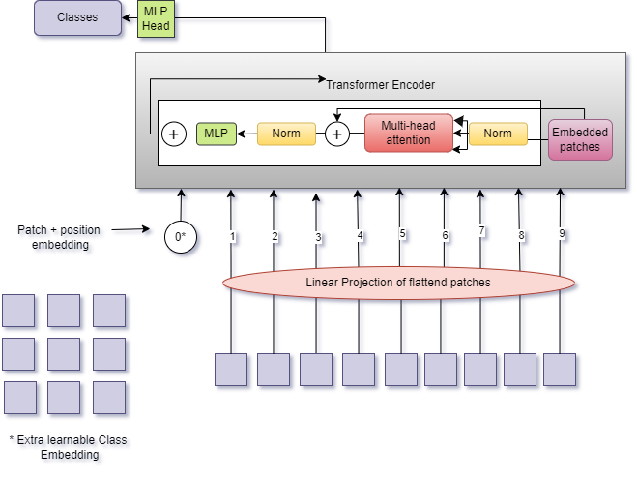

**Fig.2.**  ViT Architecture

Henceforth, ViT's adaptability and interpretability add to its importance in enhancing the performance and capabilities of the proposed system.The ViT architectural diagram (see Fig, 2) visually depicts the major components, emphasizing the function of the self-attention mechanism in information processing.

**4.3 Large Language model- Mistral-7B-v0.1**

Large language models (LLMs) are forefront technology that are prominent in NLP tasks such as comprehending and generating human-like texts. Their proficiency in understanding and contextualizing human expression have revolutionized the development of chatbots. These LLMs enable the incorporation of user-owned data for customization of chatbot to meet specific needs and cater to diverse use cases.

The proposed system uses a a 7.3 billion parameter large language model called Mistral-7B version 0.1 from Hugging face ecosystem with its specified significant features like grouped query attention, sliding window attention and Byte-fallback BPE Tokenizer has been deployed into the system to make an interactive and intelligent chatbot. It is developed for the use of long text generation and has been more efficient and has a quantized approach in its working. This technology benefits in grouping the input tokens and rejects focussing on similar grouped tokens each and also by restricting tokens and taking some tokens at a time, it ensures the dependency on local relationship of queries and provides an enhanced efficiency in generating answers with reduced computing cost. It ensures handling long-range dependencies in a better way and has a hybrid approach of tokenization with byte-pair encoding. This makes sure the chatbot can have efficient processing of user queries and responses, even if they are lengthy or contain unusual words.

**4.4 Frontend Framework**

A publicly available and free framework called Streamlit makes it easy to create and distribute web applications for data science and machine learning. It is a Python-based library created with machine learning engineers in mind. When users input images, the ViT model automatically analyzes them for identification and shows the findings in the Streamlit interface. Integrating the Mistral-7B, the chatbot can improve user involvement and information sharing by offering interactive answers to questions about medicinal plants.

**4.5 Implementation**

The suggested medical plant identification system makes use of a pre-trained Vision Transformer (ViT) model for image recognition, which is obtained via Hugging Face's model hub. There are two main artificial intelligence (AI) workload aspects in the computer vision service of the proposed medicinal plant identification system using Vision Transformers (ViTs):

* **Image recognition of Medicinal Plants:** To reliably detect and categorize medicinal plants according to their visual traits, the system makes use of AI workload features connected to image recognition. In order to accomplish accurate and reliable recognition, Vision Transformers (ViTs) are employed specifically to extract complex patterns and features from the images of medicinal plants.
* **Global Contextual Understanding with ViTs:** Vision Transformers excel in capturing global contextual information from images, enabling a nuanced understanding of the entire visual scene. This feature is crucial for the proposed system, as it allows ViTs to process intricate details and relationships among different parts of medicinal plant images. The global contextual understanding enhances the accuracy and reliability of plant identification, contributing to the overall success of the medicinal plant identification system.

With the help of ViT models both the image processing and classification of medicinal plant images can be done and with the torch features of Vision Transformers, it could possibly help in image transformation that would lead to reducing the versatility in the image size, sharpensss, normalization etc. ViT image processor helps in applying various image processing techniques followed by, the dataset is separated into training, validation, and testing sets, with an average split of 80% for training and 20% for testing and then model loading, training and evaluating with the classifier has been done. The accuracy and F1 score are two evaluation measures that are used to assess the model's performance. If necessary, fine-tuning of hyperparameters, adjustment of learning rates, or inclusion of additional data may be considered to enhance the model's efficacy. Once the model is trained and evaluated satisfactorily, it is deployed for inference on new images to identify whether they contain medicinal plants.

For chatbot interaction, the implementation uses a Large Language Model (LLM), Mistral-7B-v0.1. The system effectively performs similarity searches in the database by utilizing Facebook AI Similarity Search, or Faiss, which overcomes the drawbacks of conventional query search engines that are geared for hash-based searches. This connection improves the chatbot's ability to provide in-depth knowledge based on user requests by enabling Mistral-7B-v0.1 to provide descriptive outputs about medicinal plants. Mistral-7B-v0.1 and Faiss work together to greatly enhance the system's capacity to facilitate insightful and meaningful discussions about medicinal plants.

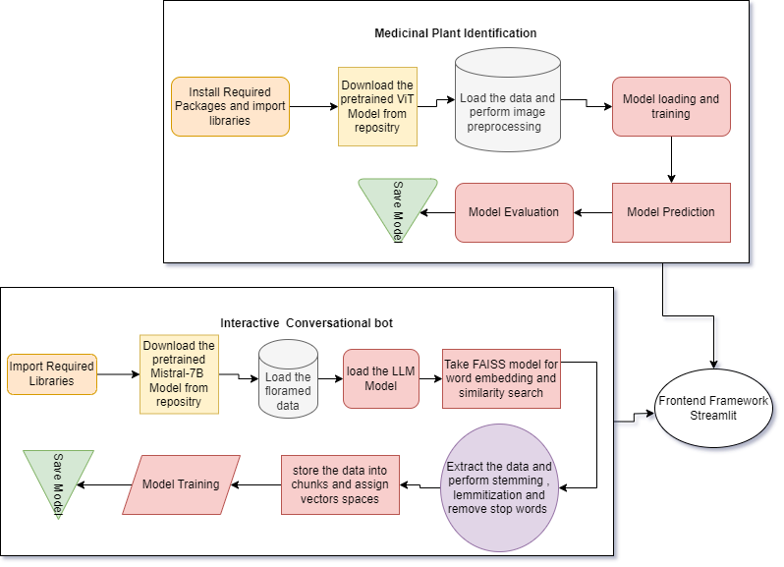

**Fig. 3.** Flowchart representing implementation walk-through of proposed system.

Streamlit powers a user-friendly web interface for plant identification, integrating Vision Transformer for image analysis, while Mistral-7B-v0.1 enhances it with interactive responses to medicinal plant queries. The User Interface would display two options, either to identify Medicinal-plants or to chat with AI. Users may select either option. On selecting identify medicinal-plants camera option will be enabled and the image can be captured to identify what plant it is and the chat with AI option would bring the interactive bot that would answer queries related to medicinal flora.

**5 Comparison and Results**

Computer vision brings an innovative approach in today’s world for various use cases and has an immense variety of properties that helps in making anything possible. Transformers are built under neural network architecture which uses self-attention mechanisms for various tasks in NLP. Combining both its characteristics, Vision Transformers (ViT) outperforms the Convolutional Neural Network models with higher accuracy and F1 score. Accuracy defines how good the model performs out of all classes and F1 score evaluates the model’s class-wise performance based on its predictive proficiency. On using a pretrained model ViT on an Indian Medicinal Plants dataset, the system achieved an accuracy of 99% and F1 score of 98% making the system error-less and efficient platform for identifying medicinal flora.

**Table 1.** Comparison of various deep learning models for medicinal plant identification.

|  |  |  |
| --- | --- | --- |
| **Model** | **Accuracy** | **F1 Score** |
| CNN | 85 % | 83.2 % |
| VGG16 | 88% | 86.7% |
| CNN, VGG16 & VGG19 | 97% | 96% |
| ViT | 99% | 98% |

Upon completing 10 training epochs with the Vision Transformer (ViT) for the image classification of medical plants, the model exhibited outstanding performance. The accuracy steadily rose to an impressive 99% of confidence level, accompanied by a noteworthy reduction in loss to 0.0341. The below fig.5 represents the accuracy and loss variation graphically during each epoch. This underscores the ViT's proficiency in capturing intricate visual features and patterns of the provided medicinal plant training data, resulting in highly accurate predictions. The model obtains an optimal point at epoch 10, which signifies successful convergence during training. Notably, the absence of discernible overfitting or underfitting indicates the ViT's robust ability to generalize effectively. The consistent improvement in both accuracy and loss during the training and testing phase on the graph, underscores the ViT's suitability for image classification tasks. To validate its performance in real-world scenarios, further evaluations on diverse datasets would be crucial.

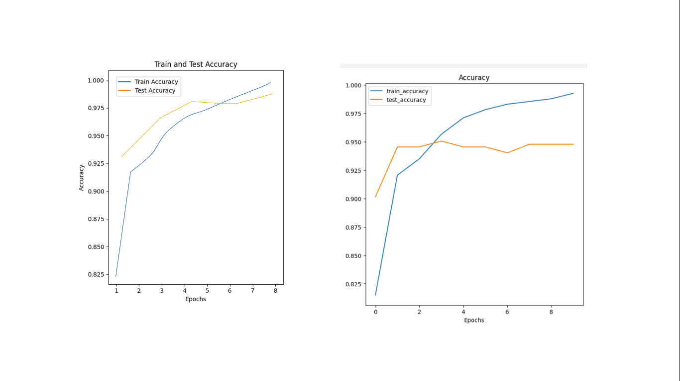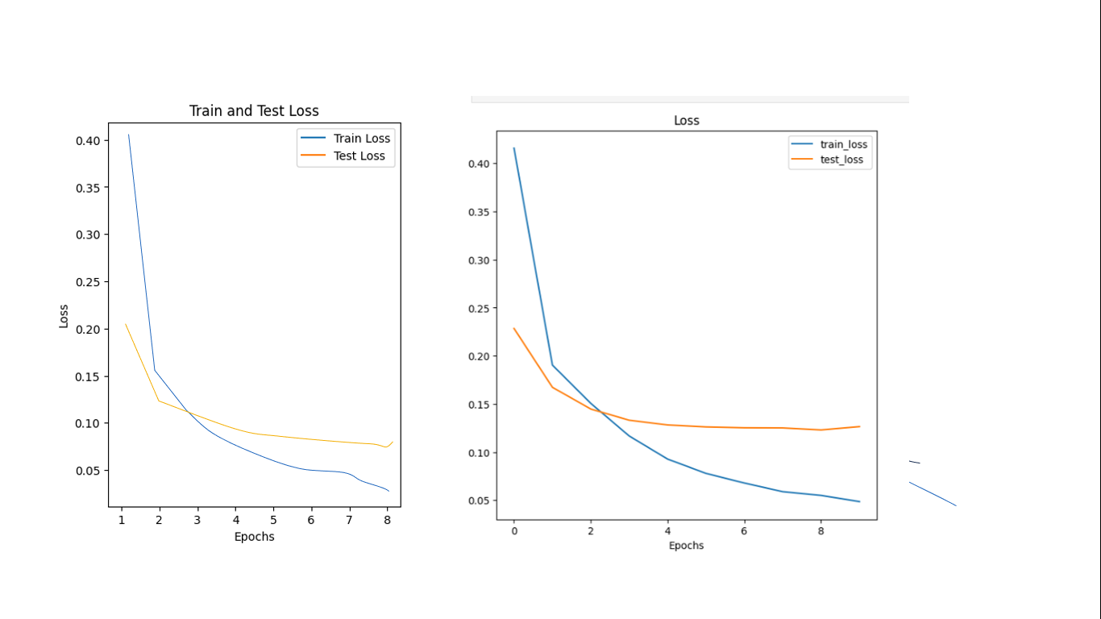

**Fig. 4.** Accuracy and Loss Graph

After evaluating the model's performance, a sample input image has been given to the model for prediction to identify the name of that medicinal plant with how confident the model is. The following fig.5 shows the output (predicted) results in varying backgrounds and conditions.

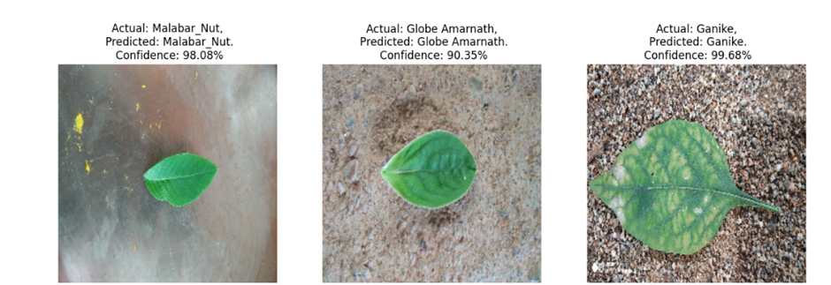 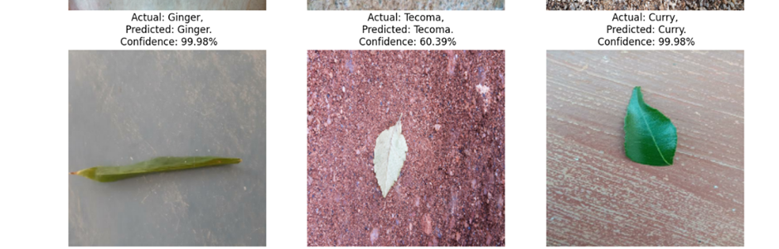 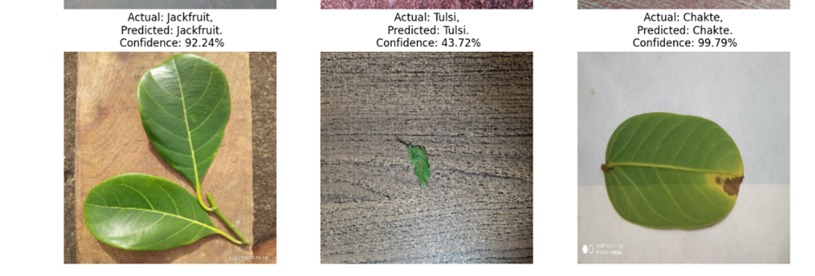

**Fig. 5.** Model Output (Medicinal Plant Prediction)

Large Language Models (LLMs) have made significant achievements and revolutionized the understanding of general purpose language within the short notice of time. Over time, pretrained models have emerged and achieved state of art performance level while outperforming on all benchmarks. One such model introduced by hugging face is Mistral 7B which proved to have better understanding than the Large Language Model LLama(3,2,1) on various levels of information regarding the therapeutic properties of medicinal plants (see Fig. 4). As a result this lets the users have meaningful, precise, and easy conversation regarding the subject on use of the chatbot .

# 

**Fig. 6.** Comparison of various LLMs for conversational bot

**6 Conclusion**

Through the utilization of state-of-the-art techniques in image processing and natural language understanding, this research has demonstrated the feasibility and effectiveness of employing AI in the field of medicinal plants. The developed system showcases its capability to accurately identify medicinal plants through image analysis, providing users with a reliable tool for plant recognition. The integration of a conversational bot enhances the user experience by offering a user-friendly interface to retrieve detailed information about identified plants. This not only facilitates the dissemination of knowledge but also encourages engagement and interaction with the natural world.

Future works can be done with continuous learning mechanisms for the AI model that would enable it to adapt to new plant species and variations. Regular updates based on user feedback and emerging botanical knowledge could enhance the model's accuracy over time. Involving traditional herbalists and botanical experts in the development process can contribute valuable insights. Their expertise can help refine the plant identification model and enrich the bot's knowledge base.

**References**

1. Dileep M.R., Pournami P.N.: AyurLeaf: A Deep Learning Approach for Classification of Medicinal Plants. In: 10th IEEE International Conference TENCON, pp. 321-325. Kochi, India (2019)
2. Sharrab Y., Al-Fraihat D., Tarawneh M., Sharieh A.: Medicinal Plants Recognition Using Deep Learning. In: IEEE International Conference on Multimedia Computing, Networking and Applications, pp. 116-122. Valencia, Spain (2023).
3. Ayumi V., Ermatita E., Abdiansah A., Noprisson H., Purba M., Utami M.: A Study on Medicinal Plant Leaf Recognition Using Artificial Intelligence. In: International Conference on Informatics, Multimedia, Cyber and Information System, pp. 40-45. Jakarta, Indonesia (2021)
4. Valdez D.B., Aliac C.J.G., Feliscuzo L.S.: Medicinal Plant Classification using Convolutional Neural Network and Transfer Learning. In: IEEE International Conference on Artificial Intelligence in Engineering and Technology, pp. 1-6. Kota Kinabalu, Malaysia (2022)
5. Sriharshitha, and et al., Proactive Headcount and Suspicious Activity Detection using YOLOv8 in Procedia Computer Science, 61-69, 2023, https://www.sciencedirect.com/science/article/pii/S1877050923020665
6. Retheneka, and et al., Enhancing the Efficiency of Lung Disease Prediction using CatBoost and Expectation Maximization Algorithms, 2022 4th International Conference on Inventive Research in Computing Applications (ICIRCA), , , 57-61, 2022, IEEE
7. Thrisha, and et al., Performance Evaluation of Improved Adaboost Framework in Randomized Phases Through Stumps, 2021 International Conference on Advancements in Electrical, Electronics, Communication, Computing and Automation (ICAECA), , , 45078, 2021, IEEE
8. Senevirathne L.P.D.S., Pathirana D.P.D.S., Silva A.L., Dissanayaka M.G.S.R., Nawinna D.P., Ganegoda D.: Mobile-based Assistive Tool to Identify & Learn Medicinal Herbs. In: 2nd International Conference on Advancements in Computing, pp. 97-102. Malabe, Sri Lanka (2020)
9. Darshana , and et al., Performance Evaluation of Improved Adaboost Framework in Randomized Phases Through Stumps, IEEE Xplore 2021, , , 45078, 2021, doi: 10.1109/ICAECA52838.2021.9675739.
10. Raghukumar A.M., Narayanan G.: Comparison Of Machine Learning Algorithms For Detection Of Medicinal Plants. In: 4th International Conference on Computing Methodologies and Communication, pp. 56-60. Erode, India ( 2020)
11. Anki P., Bustamam A., Al-Ash H.S., Sarwinda D.: High Accuracy Conversational AI Chatbot Using Deep Recurrent Neural Networks Based on BiLSTM Model. In: 3rd International Conference on Information and Communications Technology, pp. 382-387. Yogyakarta, Indonesia (2020)
12. Rajani S., Veena M.N.: Ayurvedic Plants Identification based on Machine Learning and Deep Learning Technologies. In: 4th International Conference on Emerging Research in Electronics, Computer Science and Technology, pp. 1-6. Mandya, India (2022)
13. Ratheeshkumar and et al., Performance analysis of enhanced adaboost framework in multifacet medical dataset. NVEO-NATURAL VOLATILES & ESSENTIAL OILS Journal| NVEO. 2021 Nov 7:1752-6.
14. Amuthalingeswaran., Sivakumar., Renuga P., Alexpandi S., Elamathi J., Hari S.S.: Identification of Medicinal Plant's and Their Usage by Using Deep Learning. In: 3rd International Conference on Trends in Electronics and Informatics, pp. 886-890. Tirunelveli, India (2019)
15. Prasad S., Singh P.P.: Medicinal plant leaf information extraction using deep features. In: IEEE International Conference TENCON, pp. 2722-2726. Penang, Malaysia (2017)
16. Trishna , and et al., A novel Sentimental Analysis framework using Gated Recurrent Units for Text Transliteration, 2023 2nd International Conference on Advancements in Electrical, Electronics, Communication, Computing and Automation (ICAECA), , , 45078, 2023, IEEE
17. Suriyavathi, and et al., Emotion Recognition using EEG Signal Classification of seed Dataset, 2023 2nd International Conference on Advancements in Electrical, Electronics, Communication, Computing and Automation (ICAECA), , , 45078, 2023, IEEE
18. Jayalath A.D.A.D.S., Nadeeshan P.V.D., Amarawansh T.G.A.G.D., Jayasuriya H.P., Nawinna D.P.: Ayurvedic Knowledge Sharing Platform with Sinhala Virtual Assistant. In: International Conference on Advancements in Computing, pp. 220-225. Malabe, Sri Lanka (2019)
19. SAKTHI GOVINDARAJU, and et al., A NOVEL AI AND RF TUTORED STUDENT LOCATING SYSTEM VIA UNSUPERVISED DATASET, Turkish Journal of Physiotherapy and Rehabilitation, 32, 2, 882-887, 2021, https://turkjphysiotherrehabil.org/pub/pdf/322/32-2-114.pdf
20. Prabha, D; , and et al., A novel machine learning approach for software reliability growth modelling with pareto distribution function, Soft Computing, 23, 18, 8379-8387, 2019, Springer Berlin Heidelberg Berlin/Heidelberg
21. Khorashadizadeh H., Monsefi R., Foolad S.: Attention-based Convolutional Neural Network for Answer Selection using BERT. In: 8th Iranian Joint Congress on Fuzzy and intelligent Systems, pp. 121-126. Mashhad, Iran (2020)
22. Amitha K, and et al., A Novel AI Framework for Anomaly Detection and Predictive Maintenance in Heterogenous Networks, International Journal of Innovative Research in Computer and Communication Engineering, 11, 7, 9083-9086, 2023, DOI: 10.15680/IJIRCCE.2023.1107011